

**Faculty of engineering - Shoubra**

**Benha University**

**Research Article / Research Project / Literature Review**

In fulfillment of the requirements of

|  |  |
| --- | --- |
| **Department** | **Engineering Mathematics and Physics** |
| **Division** | **-----------** |
| **Academic Year** | **2019-2020 Preparatory** |
| **Course name** | **Computer** |
| **Course code** | **ECE001** |

**Title: -**

**Build a website on Big Data**

By:

|  |  |  |  |
| --- | --- | --- | --- |
|  | Name | Edu mail | B.N |
| 1 | مريم مدحت محمود فهمي | Mariam195994@feng.bu.edu.eg | 892 |

**Approved by:**

|  |  |
| --- | --- |
| Examiners committee | Signature |
| Dr. Ahmed Bayoumi |  |
| Dr. Shady Elmashad |  |
| Dr. Abdelhamid Attaby |  |

***My GitHub Link:***

***Application brief:***

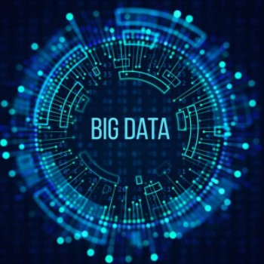

**Big data** is a field that treats ways to analyze, systematically extract information from, or otherwise deal with data sets that are too large or complex to be dealt with by traditional data-processing application software. Data with many cases (rows) offer greater statistical power, while data with higher complexity (more attributes or columns) may lead to a higher false discovery rate. Big data challenges include capturing data, data storage, data analysis, search, sharing, transfer, visualization, querying, updating, information privacy and data source. Big data was originally associated with three key concepts: volume, variety, and velocity. When we handle big data, we may not sample but simply observe and track what happens. Therefore, big data often includes data with sizes that exceed the capacity of traditional software to process within an acceptable time and value.

***Big Data Applications:***

* [Government](https://en.wikipedia.org/wiki/Big_data#Government)
* [International development](https://en.wikipedia.org/wiki/Big_data#International_development)
* [Healthcare](https://en.wikipedia.org/wiki/Big_data#Healthcare)
* [Education](https://en.wikipedia.org/wiki/Big_data#Education)
* [Media](https://en.wikipedia.org/wiki/Big_data#Media)
* [Insurance](https://en.wikipedia.org/wiki/Big_data#Insurance)
* [Internet of Things (IoT)](https://en.wikipedia.org/wiki/Big_data#Internet_of_Things_(IoT))
* [Information technology](https://en.wikipedia.org/wiki/Big_data#Information_technology)

**Summary**

* **Big Data** is defined as data that is huge in size. Big data is a term used to describe a collection of data that is huge in size and yet growing exponentially with time.
* Examples of Big Data generation includes stock exchanges, social media sites, jet engines, etc.
* Big Data could be 1) Structured, 2) Unstructured, 3) Semi-structured
* Volume, Variety, Velocity, and Variability are few Characteristics of Big data
* Improved customer service, better operational efficiency, Better Decision Making are few advantages of Big data

**____________________________________________**

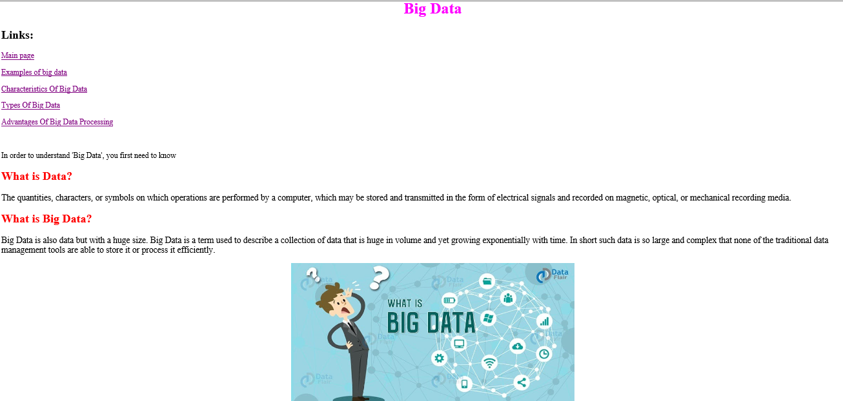**Screenshots:**



